chapter 2

system design

The System design section gives brief idea about the basic modules of the system, schema design of the database, procedural design, logic diagrams and entity relationship diagram of the database that are used in the project.

**2.1 SCHEMA DIAGRAM**

Figure 2.1 shows the Schema diagram Dairy management system

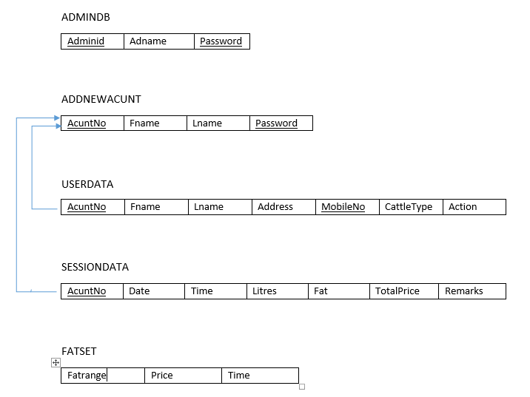

**Fig 2.1: Schema Diagram**

**2.2 ER DIAGRAM**

Figure 2.2 shows the ER diagram of Dairy management system

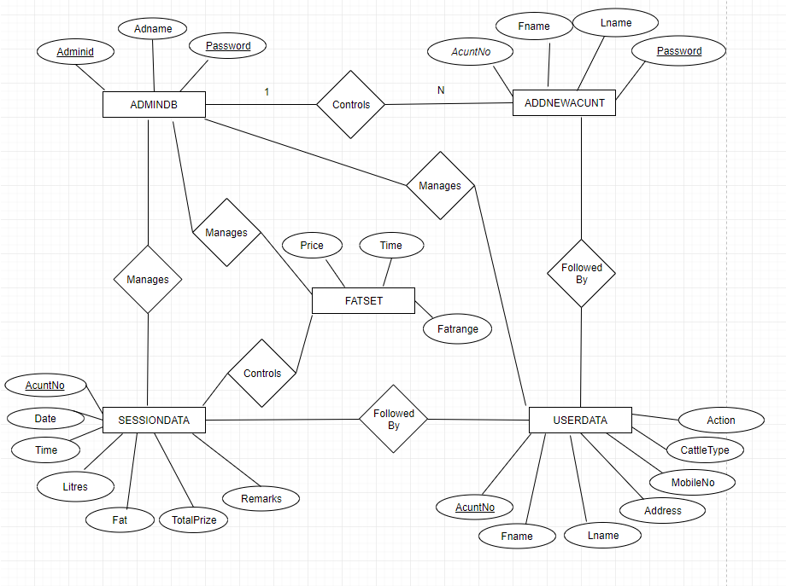

**Fig 2.2: ER Diagram**